Chapter 1 Rational Numbers

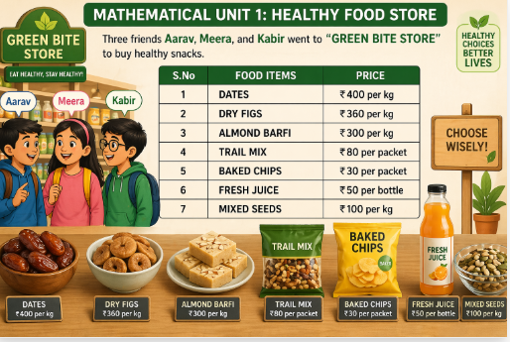

- Aarav buys 1/2 kg dates, 1/4 kg dry figs, and 1/4 kg almond barfi. What is the total cost?
A. Rs 350
B. Rs 365
C. Rs 370
D. Rs 390
Answer: B

- If Aarav had Rs 500 and spent Rs 370, what fraction of his money is left?
A. 1/4
B. 13/50
C. 2/5
D. 3/10
Answer: B

- What is the total cost of 1/2 kg mixed seeds and 1/2 kg dates?
A. Rs 200
B. Rs 220
C. Rs 240
D. Rs 250
Answer: D

- What is the cost of 5/2 kg mixed seeds?
A. Rs 200
B. Rs 225
C. Rs 250
D. Rs 300
Answer: C

- Which is greater in cost?
A. 1/2 kg dates
B. 3/4 kg almond barfi
C. Both equal
D. Cannot be determined
Answer: C

ASSERTION–REASON MCQs
Options:
A. Both true, Reason explains
B. Both true, Reason not explanation
C. Assertion true, Reason false
D. Assertion false, Reason true
Q1.
Assertion: (-4)/(-9) is positive.
Reason: Same signs give positive rational number.
Answer: A

Q2.
Assertion: 6/(-8) = -3/4 (standard form).
Reason: Denominator must be positive and no common factors.
Answer: A

Q3.
Assertion: Rational numbers are closed under subtraction.
Reason: Difference of two rational numbers is rational.
Answer: A

Q4.
Assertion: Division of rational numbers is commutative.
Reason: (3/5) ÷ (1/5) ≠ (1/5) ÷ (3/5).
Answer: D

